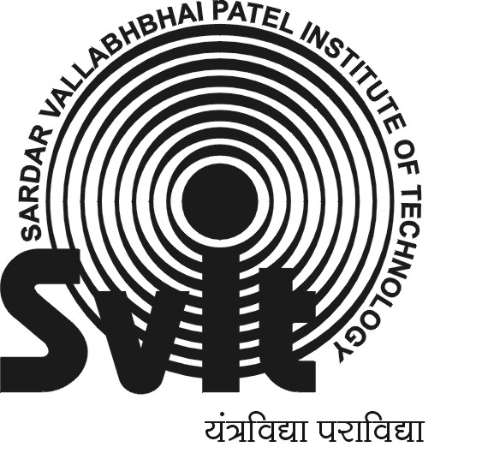
SARDAR VALLABHBHAI PATEL INSTITUTE OF TECHNOLOGY , INFORMATION TECHNOLOGY DEPARTMENT

Subject Name : Software Engineering | Semester : VI
Subject Code : 2160701 | Academic year : 2018-19

Practical No. | Practical Title
 | Introduction to Software Engineering
Study of different software engineering models.
- Waterfall model, prototype model, incremental model, spiral model and RAD models.
Documentation of Software Requirement Engineering.
- Student has to include SRS document for current semester project.
Documentation of System Design using procedural approach or Object Oriented approach
- DFD/UML, ER-Diagram for current semester project.
5. | Documentation of Data Dictionary  - Student has to create data dictionary of their database for current semester project.
6 | Documentation of System Design (form design)  - Student has to do form design for current semester project.
7 | Study of different software cost estimation models.  - LOC and FP, COCOMO
8 | Software Development tools and techniques (CASE).
9 | Study of Software testing using testing tools  - Black box testing and white box testing
10 | CASE STUDY: study of software quality assurance (SQA)  standards.  - SQA Activities, ISO, CMM.
BEYOND SYLLABUS
11 | Explore the Microsoft Project tool and explain the characteristics and scheduling with GANTT chart and PERT Chart.

Course coordinator I/C HOD
Paresh Patel I.T department,
I.T department S.V.I.T, Vasad
S.V.I.T, Vasad

